1. ChatGPT, about 150 words( wordsnot too much or too little really), generate many times, it is best to achieve a score of 88 or more for the first time, which is convenient for further modification.
2. Modify the essay following the prompts. Maybe 5~10 times.
3. Try to complete it within half an hour.

The instruction template of ChatGPT:

Title: “xxxxx”.

Requirements:

1. Write an essay of about 150 words.

2. Reach a score of 90 or more on “http://www.pigai.org/”.

(Note: this is only my template, of course you could have your own template!)

Result display:

1. Generate once :

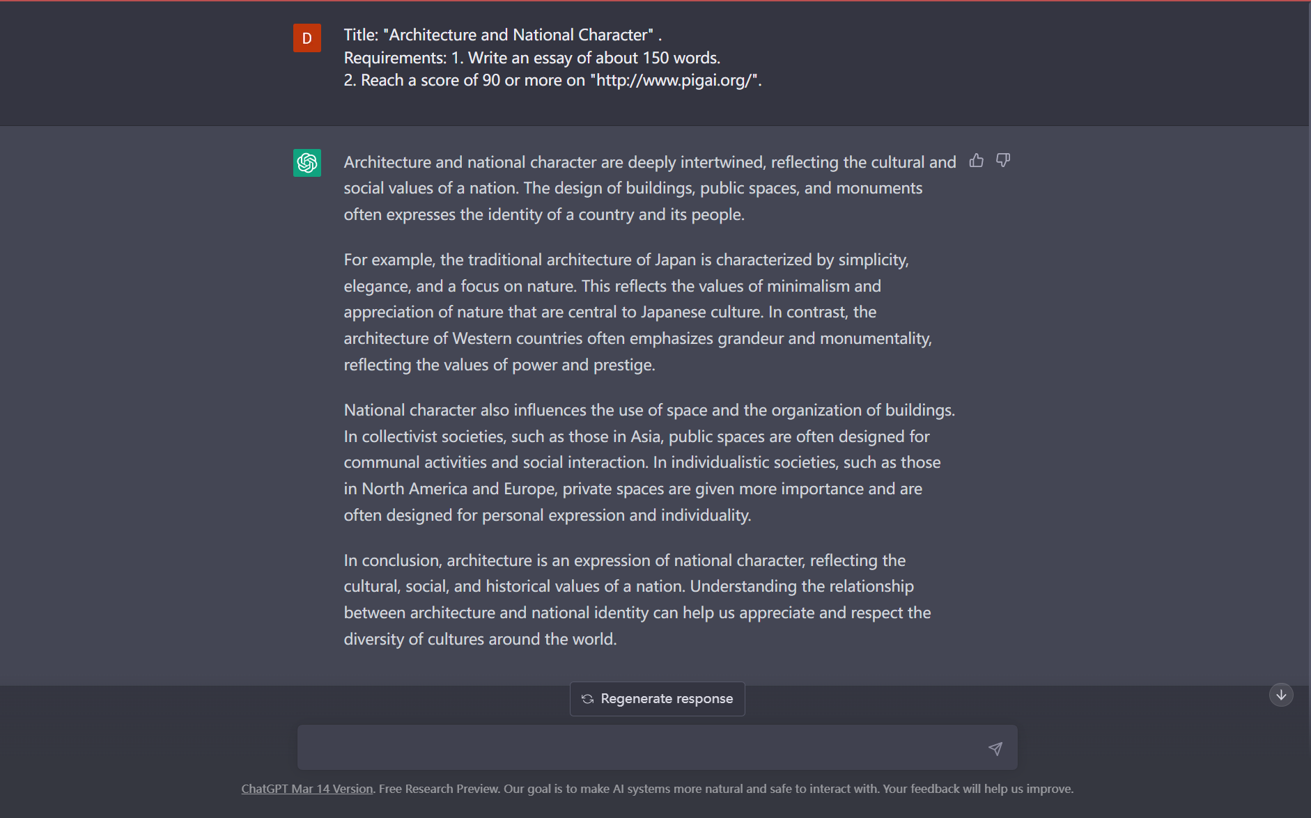

1. The first scoring result :

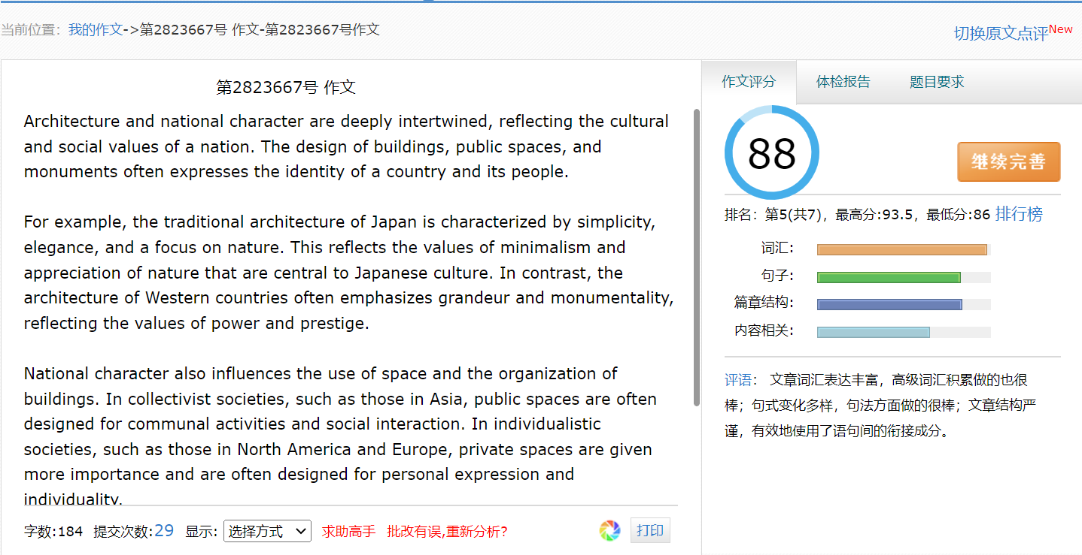

3.The final scoring result after modification (note: not consistent with the above picture, just to illustrate the steps) :

